Tableau and Power BI session
Assignment 01

- Install Power BI Desktop and share the final screenshot of the report view page which appears when power desktop starts
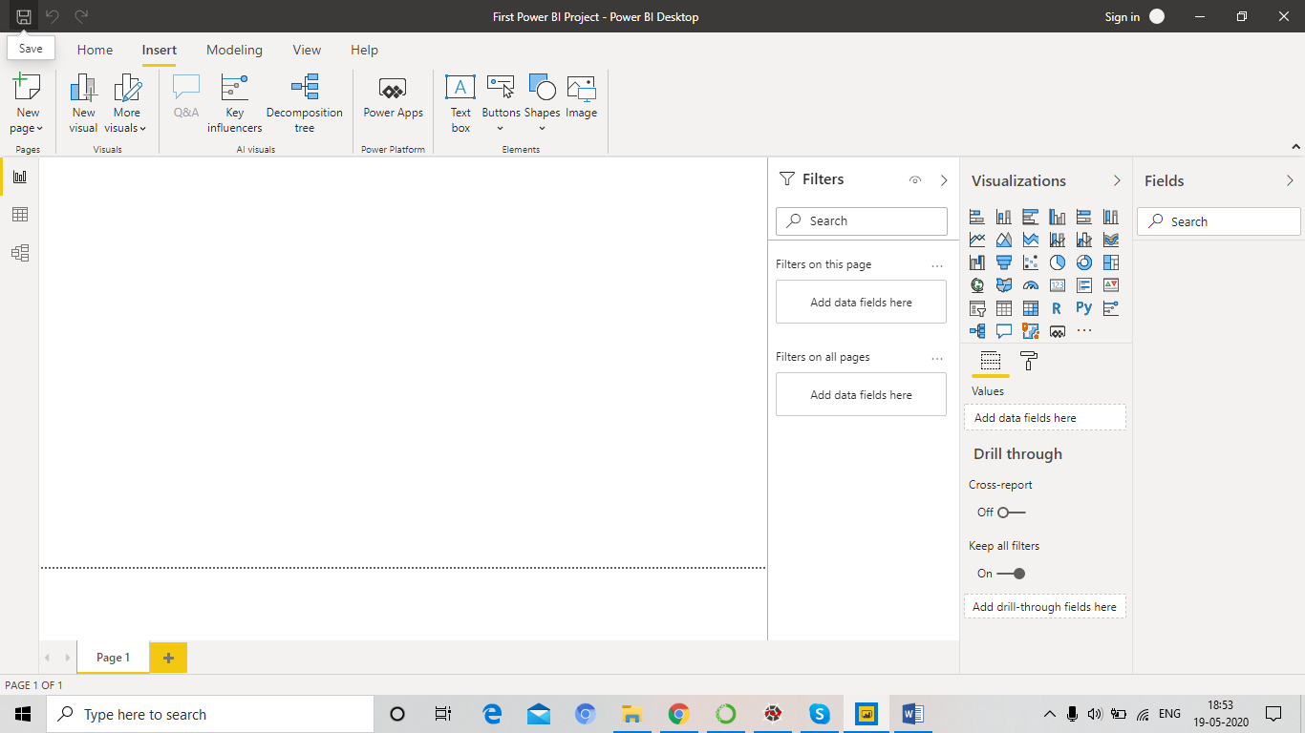
- Prepare a document and with the following screenshot
− Report View
− Data View
− Model View
− Power Query Editor
− Advance Editor

Report View w.r.t Employee data set
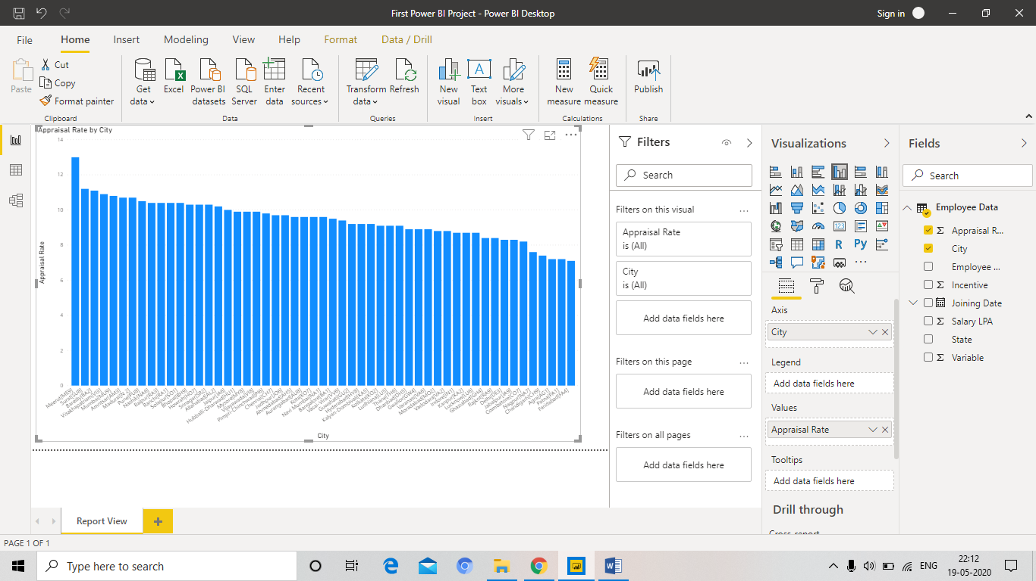

Data View w.r.t Employee Data set

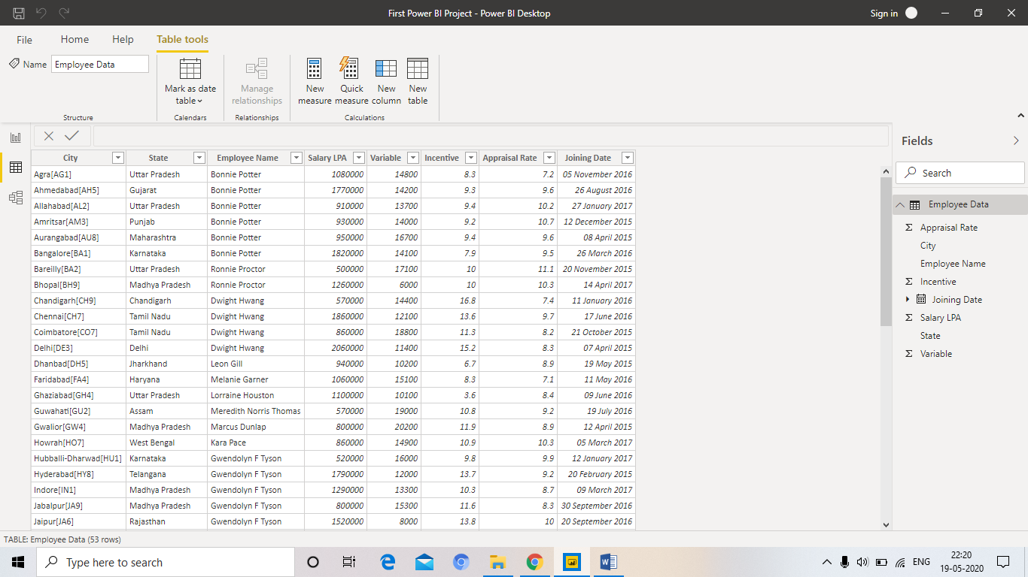

Model View w.r.t Employee Data set and 2013 Store dataset.

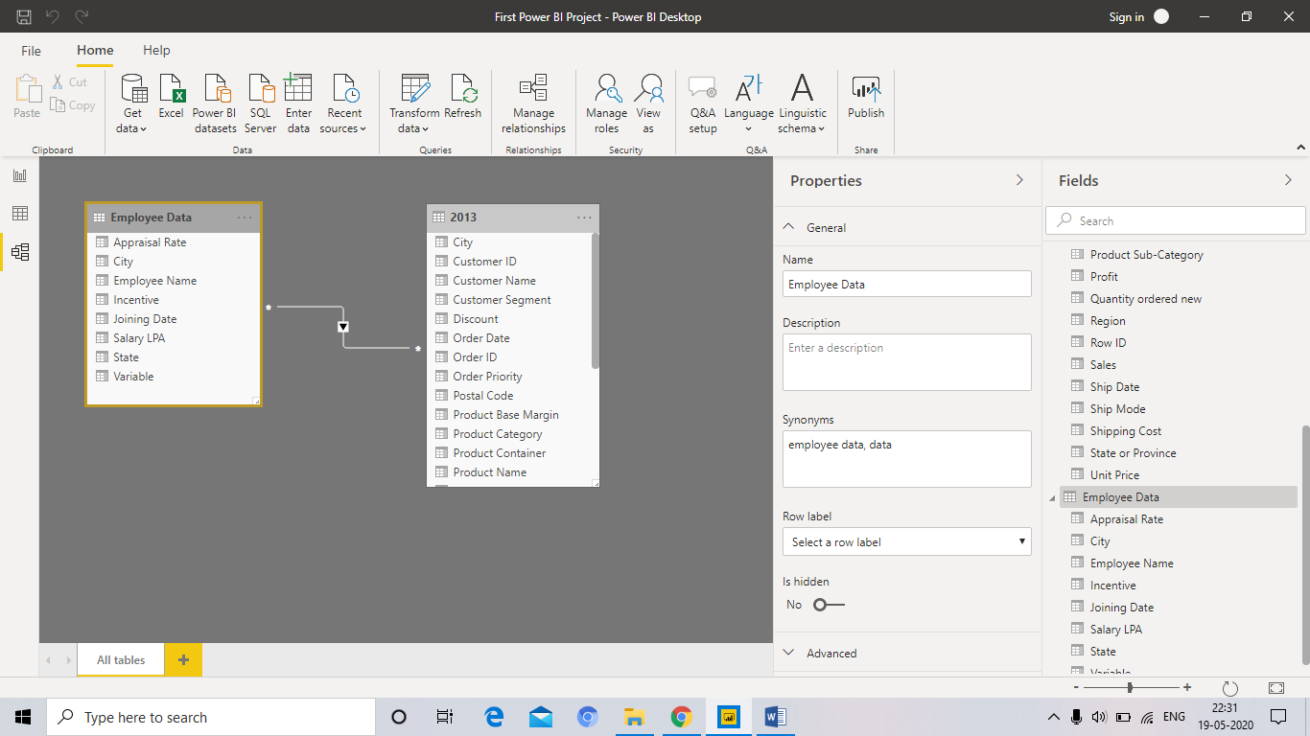

many – to- many relationship is been displayed in the above scenario.

Power Query Editor w.r.t Employee Dataset

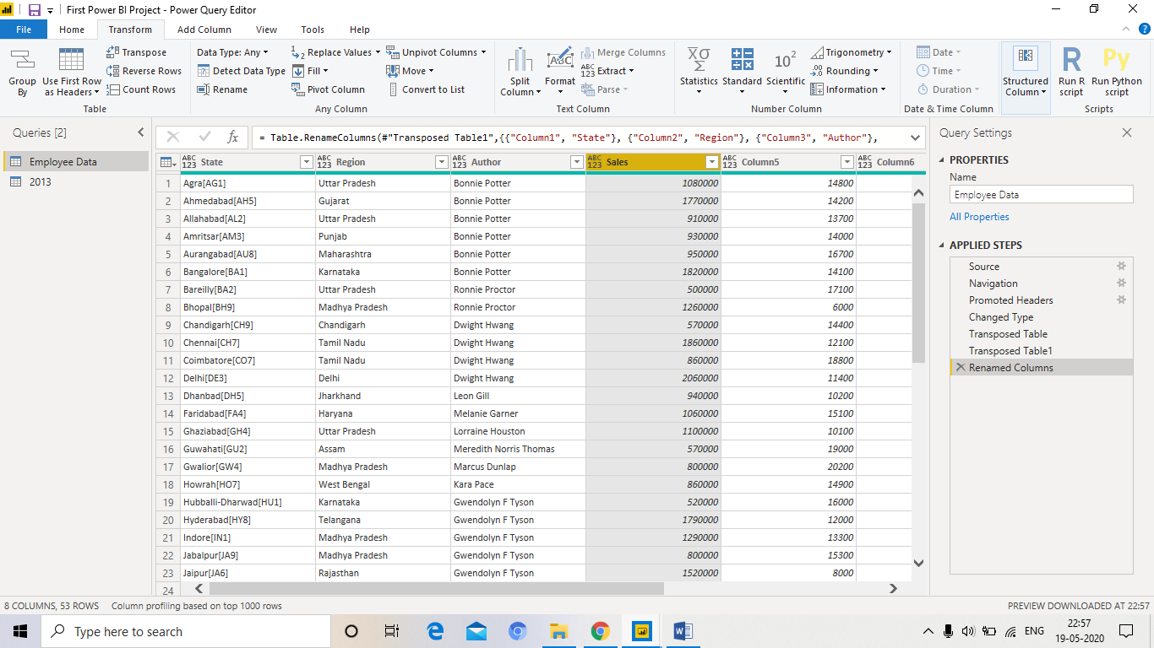

Advance Editor

